Day79 - Task37 - Kubernetes(Part-01)

1. Setup Minikube in your local machine
- First you need to install the minikube package from -
- https://minikube.sigs.k8s.io/docs/start/
- Then copy the package url and paste it in the power shell
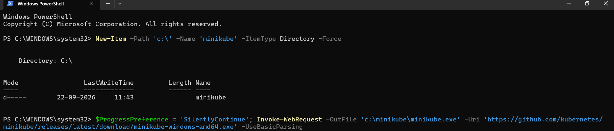

- Now set the environmental path
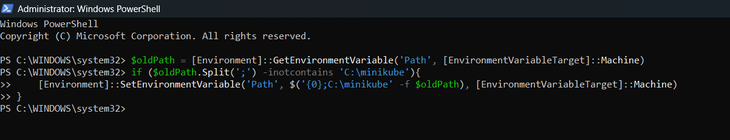

- check whether it has been downloaded or not using minikube version
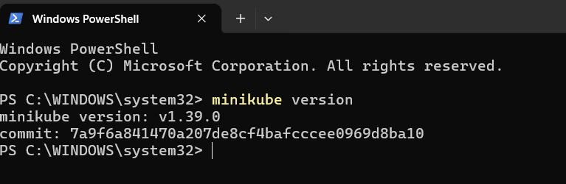

2. Setup k8s master and two worker nodes on ubuntu.
- Setup 3 nodes k8s cluster, 1 master and 2 node machines
- I have created 3 instances
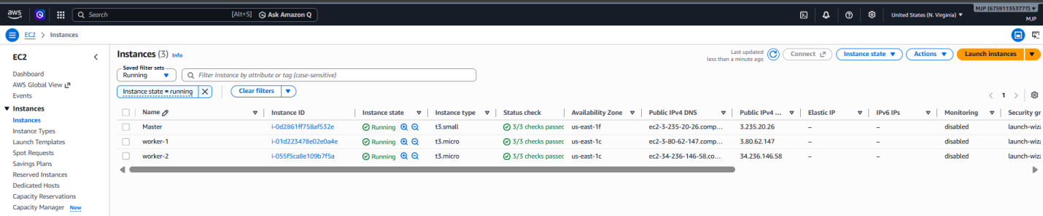

- Remove the swap memory from three instances using sudo swapoff -a and verify using free -h
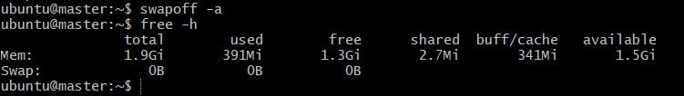
- # Install containerd
sudo apt-get update
sudo apt-get install -y containerd
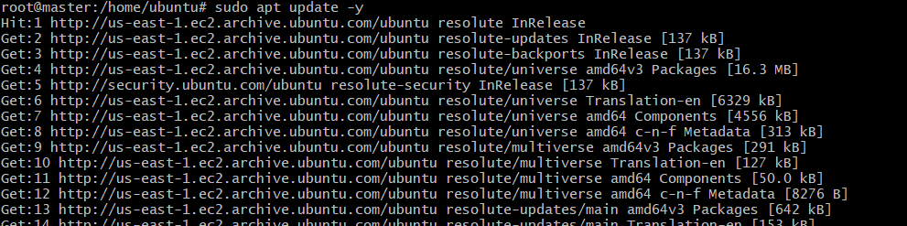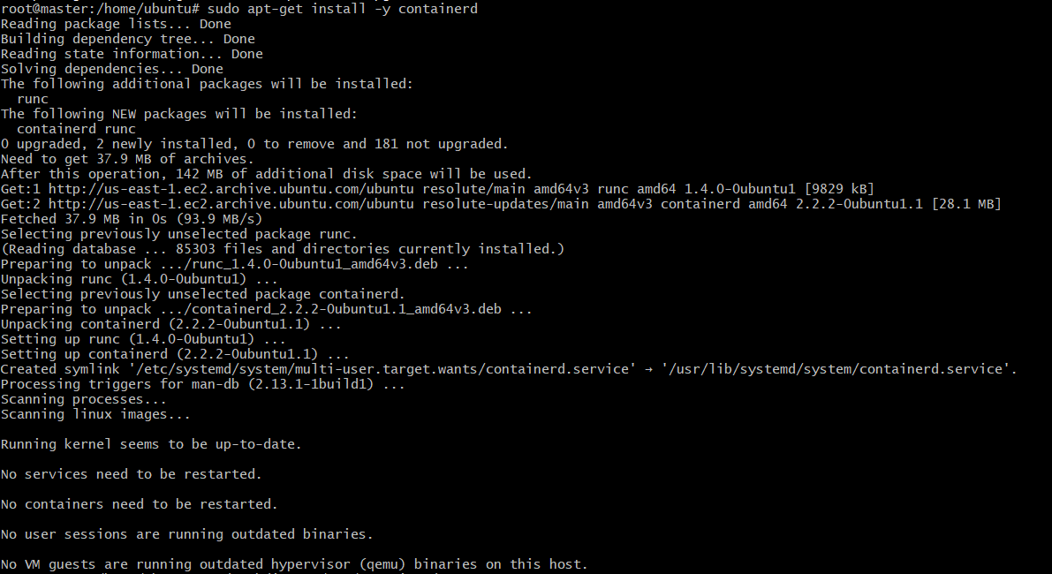
- # Enable SystemdCgroup in containerd
- sudo mkdir -p /etc/containerd containerd config default | sudo tee /etc/containerd/config.toml > /dev/null
- sudo sed -i 's/SystemdCgroup = false/SystemdCgroup = true/g' /etc/containerd/config.toml
- sudo systemctl restart containerd
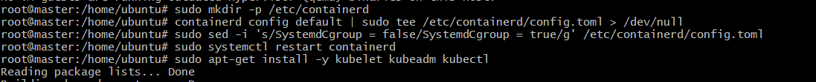
- we need to setup networking and configure master and worker nodes

- # Add Kubernetes repository & install packages
- Create the keyrings directory and download the official Kubernetes signing key to verify the key file exists : ls -l /etc/apt/keyrings/kubernetes-apt-keyring.gpg
- Add the Kubernetes package repository definition to your APT sources list

- sudo apt-get update
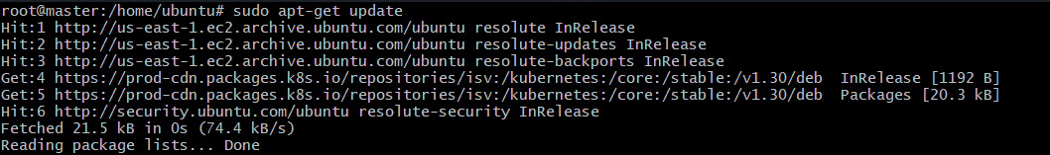
- sudo apt-get install -y kubelet kubeadm kubectl
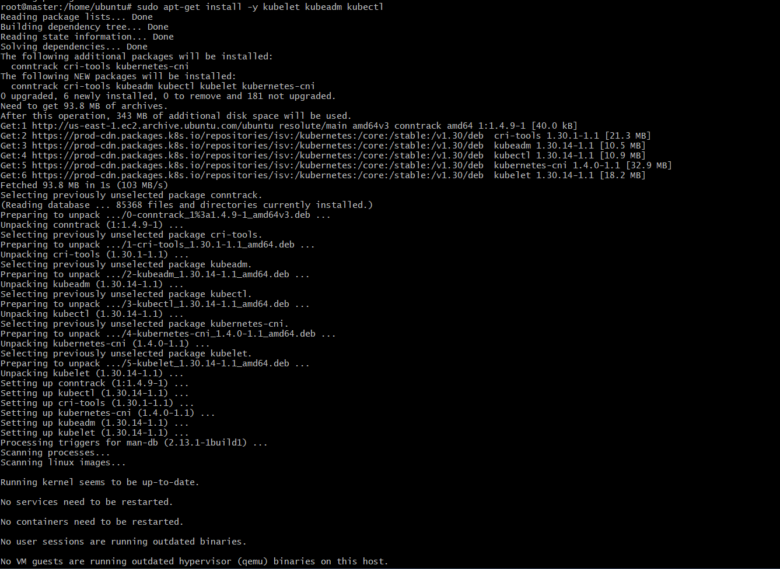

- sudo apt-mark hold kubelet kubeadm kubectl
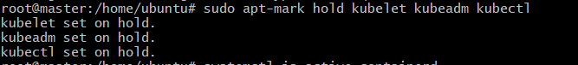
- Verification: Run systemctl is-active containerd to confirm active & run kubeadm version to verify successful installation.

- Initialize Kubernetes on the master node and configure local administrative credentials
- sudo kubeadm init --pod-network-cidr=10.244.0.0/16
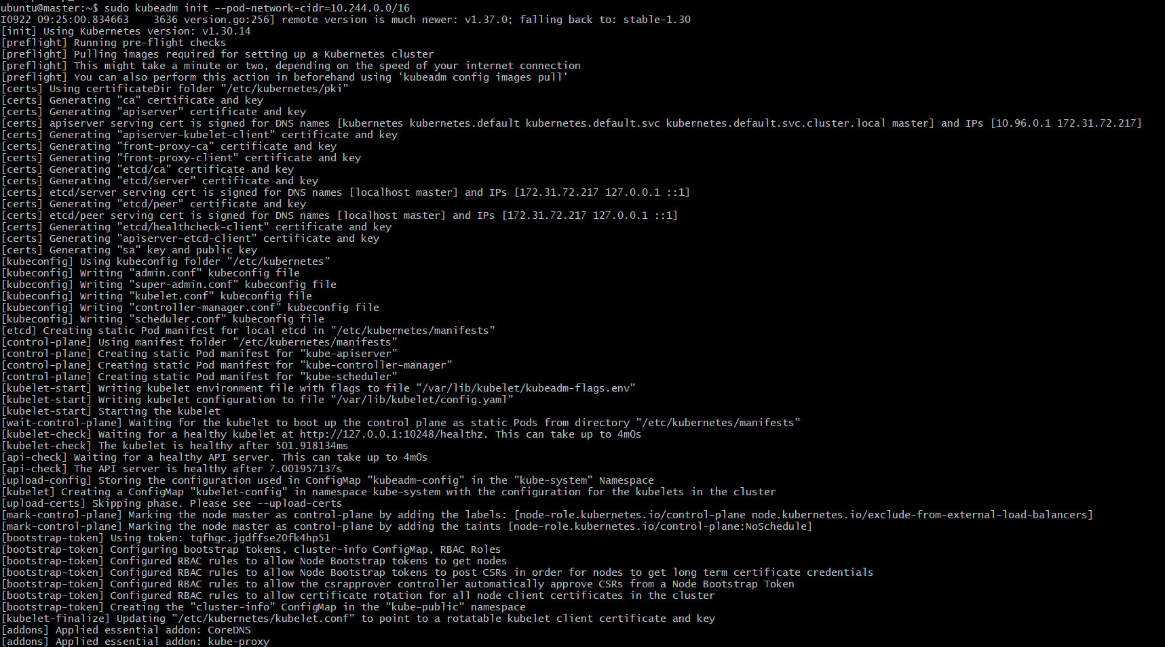
- Configure admin kubectl context
mkdir -p $HOME/.kube
sudo cp -i /etc/kubernetes/admin.conf $HOME/.kube/config
sudo chown $(id -u):$(id -g) $HOME/.kube/config
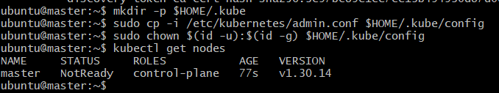
- Deploy Pod Network Plugin (Flannel)
Install Flannel CNI so pods on different nodes can communicate
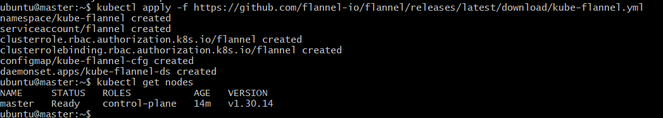
- Run the kubeadm join command (printed at the end of kubeadm init output) on both worker nodes using sudo:
- sudo kubeadm join <MASTER_IP>:6443 --token <TOKEN> --discovery-token-ca-cert-hash sha256:<HASH>
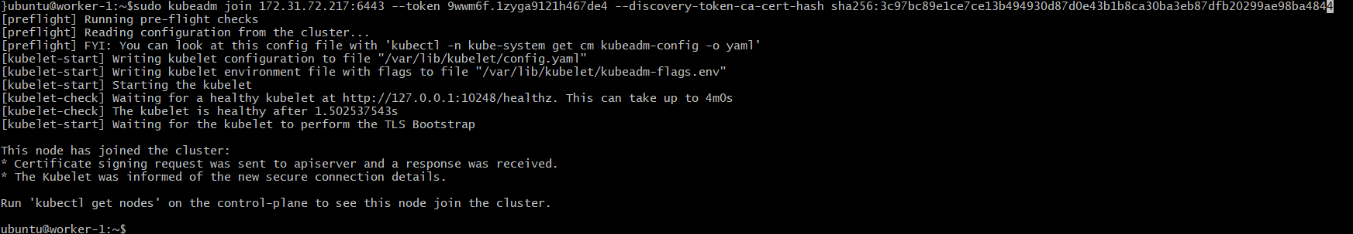
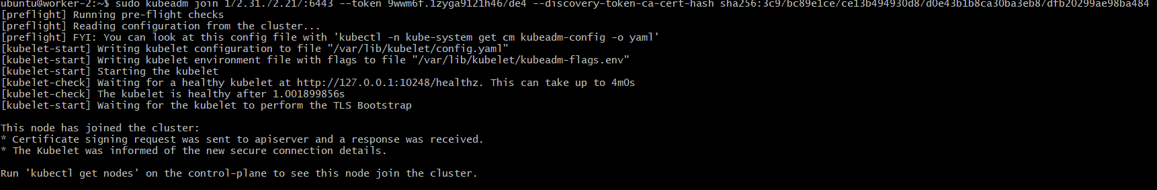
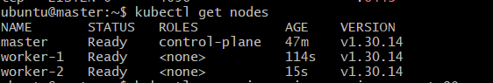
3. Run one nginx pod
- Create an NGINX pod on the cluster and test connectivity
- # Create NGINX pod
kubectl run nginx --image=nginx --port=80
- # Get Pod IP address and details
kubectl get pod nginx -o wide

- expose the port no
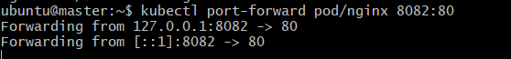
- View Detailed Info (IP, Node placement, Events) using kubectl describe pod nginx)
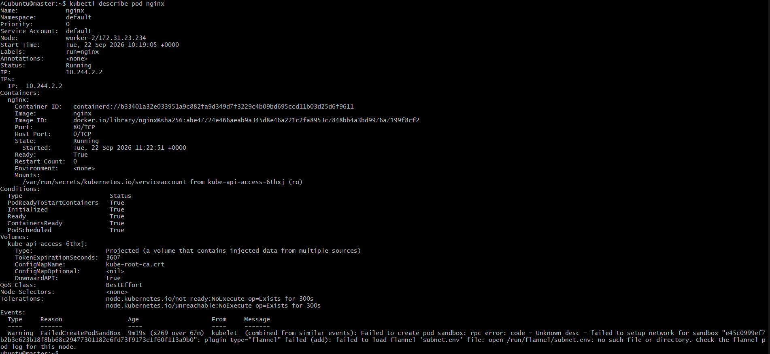
4. Mugup Master and slave components on k8s

Node Type | Component | Core Function
Control Plane (Master) | kube-apiserver | Primary API gateway; handles all REST requests and cluster commands.
Control Plane (Master) | etcd | Distributed key-value store; saves all cluster state data and configs.
Control Plane (Master) | kube-scheduler | Assigns unscheduled Pods to suitable worker nodes based on resources.
Control Plane (Master) | kube-controller-manager | Runs control loops (node, pod replication, endpoint management) to maintain desired state.
Control Plane (Master) | cloud-controller-manager | Links cluster to cloud provider APIs (AWS/GCP load balancers, storage).
Worker Node | kubelet | Main node agent; receives PodSpecs from master and ensures containers are running.
Worker Node | kube-proxy | Network proxy; manages node IP routing rules (iptables/IPVS) for Pod traffic.
Worker Node | Container Runtime | Engine responsible for pulling images and running containers (e.g., containerd, CRI-O).

Master Node (Control Plane)
- kube-apiserver: The central communication hub. Every request from kubectl, worker nodes, or dashboard passes through the API server for authentication and authorization.
- etcd: The single source of truth for the entire cluster. Holds all configuration files, secrets, and current deployment states.
- kube-scheduler: Reads resource requirements, taints, tolerations, and affinity rules, then selects the best worker node for newly created pods.
- kube-controller-manager: Runs background controllers to ensure the cluster's actual state matches the defined target state (e.g., replacing dead pods, updating service endpoints).
- cloud-controller-manager: Abstracts cloud-specific resources like managed load balancers, persistent disks, and cloud VM instances.

Worker Node (Data Plane)
- kubelet: The node manager. Reads container manifests assigned to its node and instructs the container runtime to launch, monitor, or stop containers.
- kube-proxy: Maintains cluster networking rules. Enables network communication to Pods from inside or outside the cluster by managing packet routing.
- Container Runtime: The underlying software that executes container processes (e.g., containerd, CRI-O).

